LLM-AUGMENTED CONTRASTIVE LEARNING FOR MISINFORMATION DETECTION IN SOCIAL NETWORKS
Project report in partial fulfillment of the requirement for the award of the degree of Bachelor of Technology
In Computer Science and Engineering (Internet of Things, Cyber Security, Blockchain Technology)
Submitted By:
Faishal Abrar - Enrolment No. 12023002029050
Kislay Bhardwaj - Enrolment No. 12023002029042
Debrup Chakraborty - Enrolment No. 12023002029041
Adrija Pal - Enrolment No. 12023002029008
Arunavo Bhowal - Enrolment No. 12023002029023
Imon Chakraborty - Enrolment No. 12023002029055
Gairick Purakayastha - Enrolment No. 12023002029127
Subhradwip Das - Enrolment No. 12023002029147
Under the guidance of: Prof. Sangita Dutta and Prof. Dr. Arijeet Ghosh
University of Engineering & Management, Kolkata
University Area, Plot No. III-B/5, New Town, Action Area-III, Kolkata-700160

Abstract
The spread of misinformation on social networks has become a major threat to public trust, elections, healthcare communication, and crisis response. This report presents a complete misinformation detection framework based on LLM-Augmented Contrastive Learning (LACL), improved with two reliability modules: emotion-aware augmentation filtering and fact verification. The pipeline first unifies heterogeneous rumor datasets, then generates controlled text augmentation, filters low-quality samples using emotion consistency, trains a contrastive + classification model, and finally evaluates with optional fact verification. Unlike baseline LACL implementations that rely primarily on semantic similarity, our pipeline preserves emotional signal quality and enables factual grounding during final-stage verification. Experimental analysis indicates stronger class separation, improved robustness for rumor classes, and better interpretability through structured output artifacts and visual performance dashboards. The proposed architecture is modular, scalable, and suitable for future multimodal and real-time misinformation detection extensions.

Introduction
Social media platforms provide extremely fast information flow, but the same speed also amplifies false and misleading narratives. Automated misinformation detection therefore requires models that can understand semantics, emotional framing, and factual reliability.
Recent LLM-based augmentation methods improve data diversity for low-resource classes, but naive augmentation may distort emotional tone and reduce contrastive-learning quality. In misinformation tasks, emotional cues such as urgency, fear, and outrage are often discriminative, so preserving them is critical.
This project builds a practical end-to-end framework: dataset unification, augmentation, emotion filtering, contrastive learning, and final evaluation with optional fact verification. The goal is to improve both model quality and reliability in deployment-oriented workflows.

Literature Survey
- Shen et al. (IEEE TCSS, 2026): Introduced LLM-Augmented Contrastive Learning for misinformation detection and demonstrated stronger representation learning through high-quality augmentation.
- Liu et al. (AAAI, 2018): Showed early fake-news detection using propagation paths, but dependence on graph/temporal propagation signals limits immediate portability.
- Chen et al. (ICML, 2020): Established SimCLR principles and emphasized that representation quality strongly depends on augmentation quality.
- Feng et al. (ICDM, 2022): Proposed graph contrastive rumor detection with structural strengths, but less emphasis on emotional text consistency.
- Hu et al. (CIKM, 2023): Used LLMs for multi-perspective reasoning and interpretability, highlighting opportunities for stronger grounding and tighter integration.

Research Gap
- Most LACL-style systems prioritize semantic consistency but do not explicitly enforce emotional consistency between original and augmented samples.
- Fact grounding is often missing during final predictions, making systems vulnerable to fluent but unsupported outputs.
- Many pipelines are not designed as reusable, production-friendly workflows with clear stage outputs and diagnostics.

Proposed Methodology
- Stage 1 - Data Unification: The pipeline ingests Twitter, PHEME, and RumourEval style sources and normalizes schema, labels, and metadata into a single JSONL format.
- Stage 2 - LLM Augmentation: Controlled prompt-based augmentation generates semantically related text variants to improve coverage and reduce class imbalance.
- Stage 3 - Emotion Filtering: Augmented samples are scored against source emotion profiles and filtered by similarity thresholds to remove emotionally inconsistent pairs.
- Stage 4 - Contrastive + Classifier Training: A BERT encoder with projection head is trained using contrastive objectives, followed by supervised classification.
- Stage 5 - Final Evaluation: Live CL inference outputs baseline predictions. Optional fact verification then refines rumor-class decisions through either Gemini+Wikipedia flow or Wikipedia-only mode.
- Stage 6 - Reporting and Visualization: Metrics, class reports, and dedicated matplotlib plots (bar, line, support, and heatmap) are generated for analysis and presentation.

Result and Analysis
Test Accuracy: 0.8678
Class | Precision | Recall | F1-Score | Support
false | 0.8421 | 0.8016 | 0.8213 | 251
non-rumor | 0.9015 | 0.9457 | 0.9231 | 920
true | 0.8364 | 0.8179 | 0.8270 | 335
unverified | 0.8296 | 0.7817 | 0.8049 | 257
Accuracy |  |  | 0.8678 | 1763
Macro Avg | 0.8524 | 0.8367 | 0.8441 | 1763
Weighted Avg | 0.8659 | 0.8678 | 0.8665 | 1763
Performance Visualizations:
Class Metrics Bar
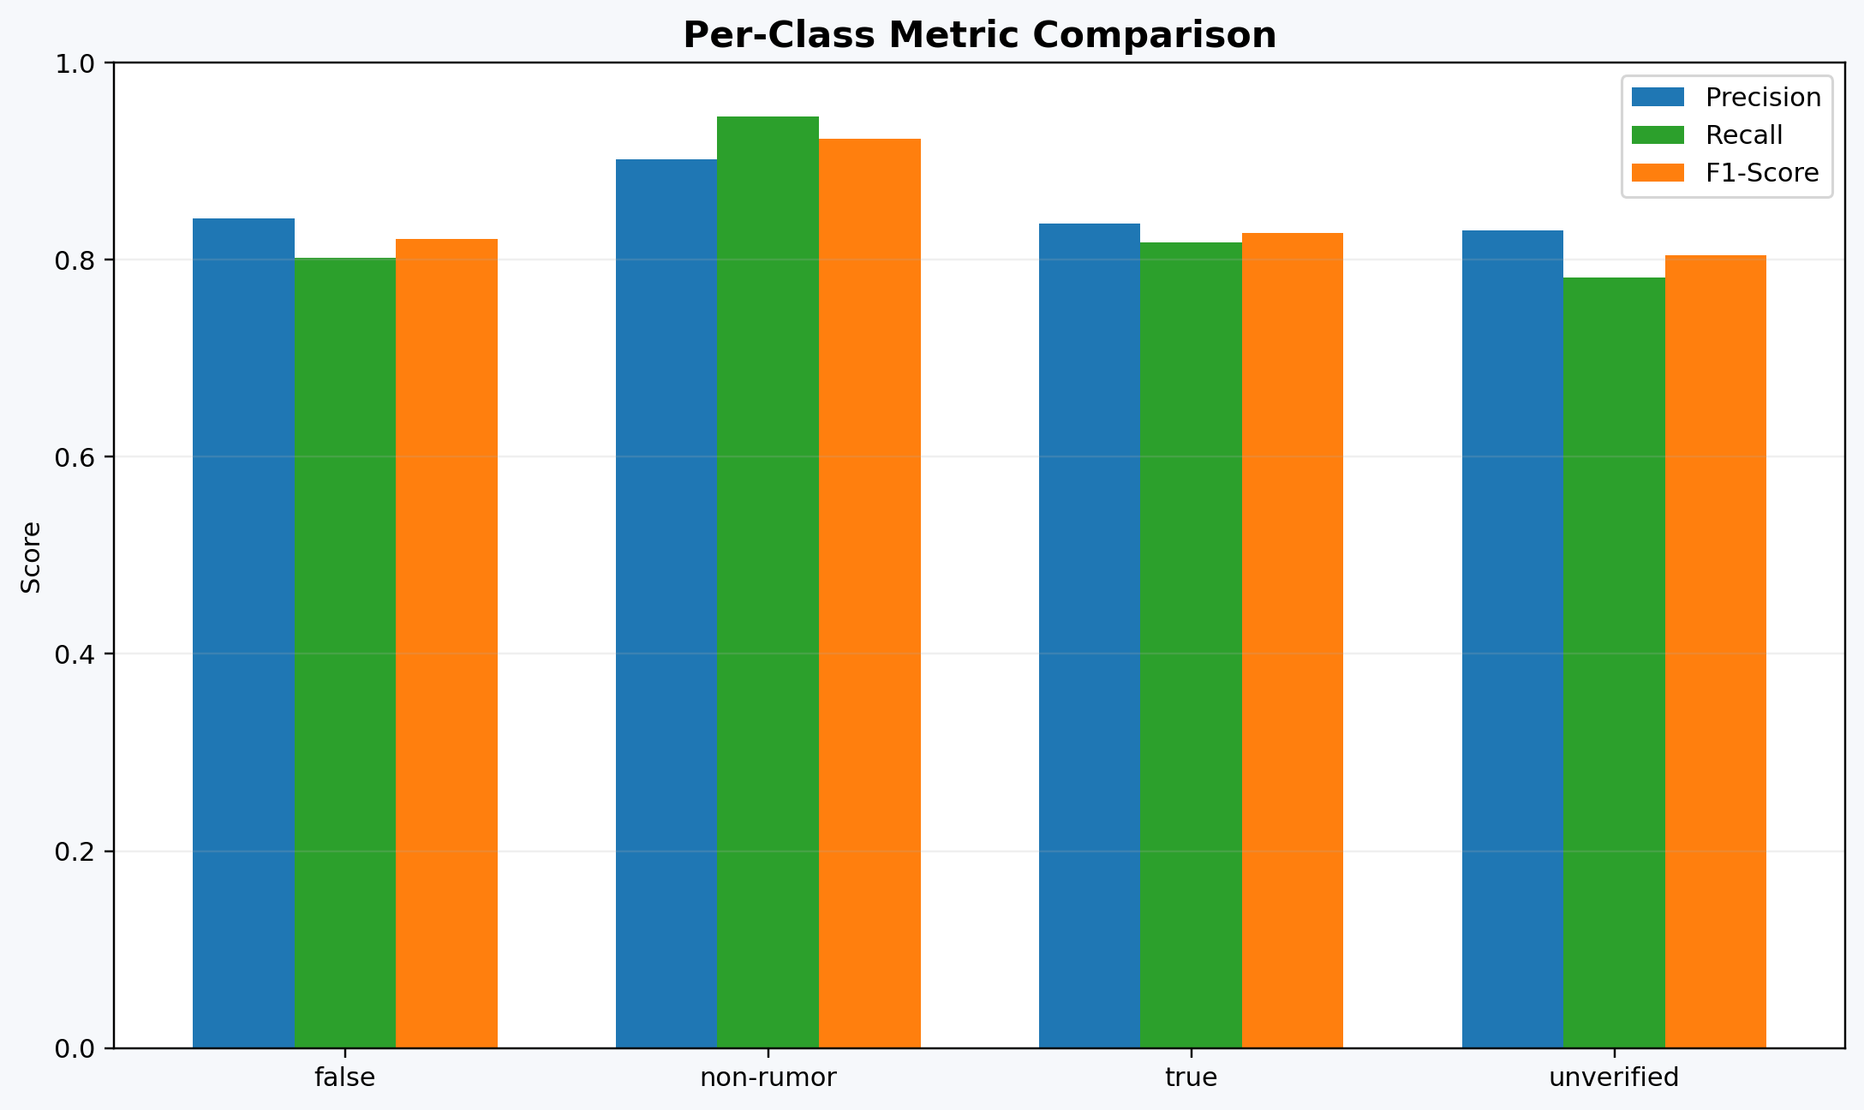
Class Support Bar
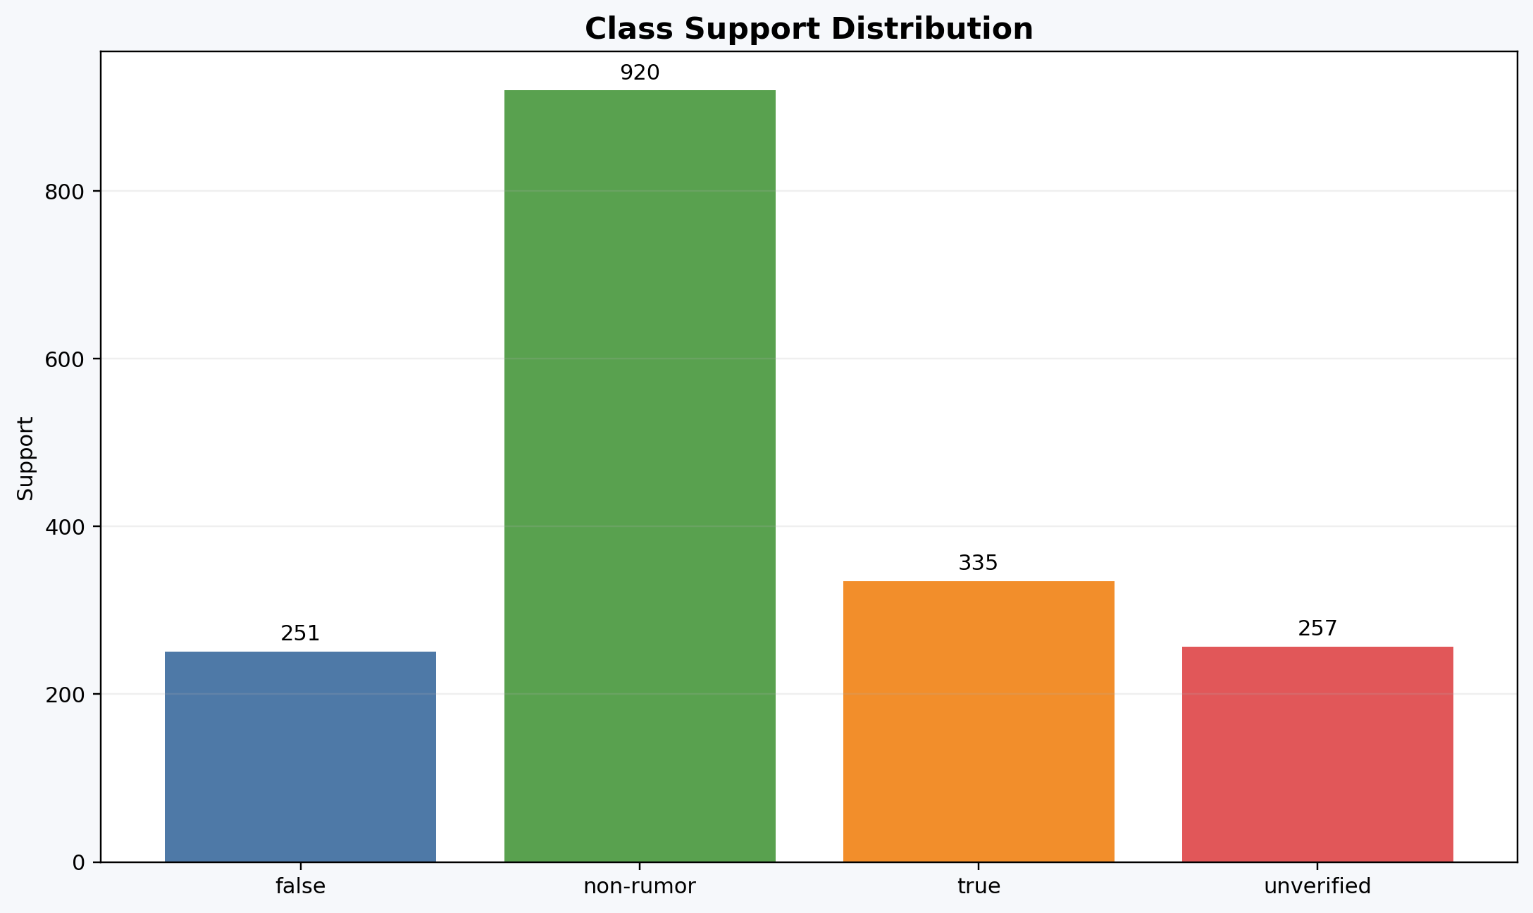
Summary Metrics Bar
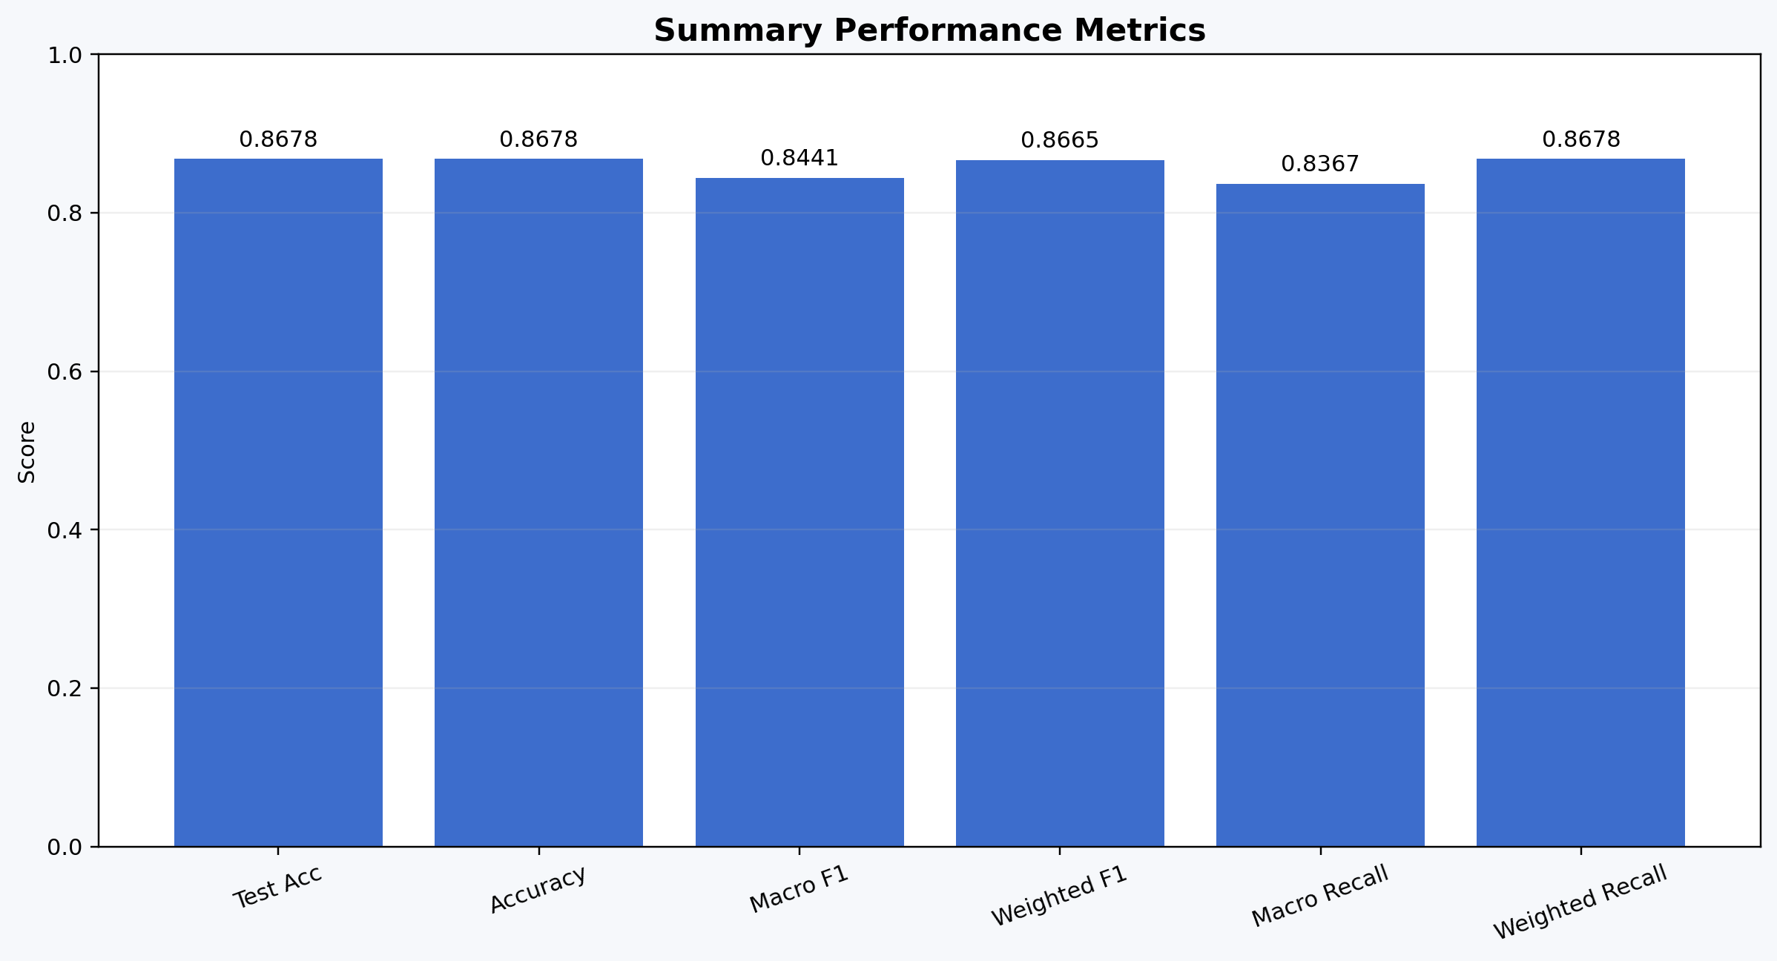
Class Metrics Line
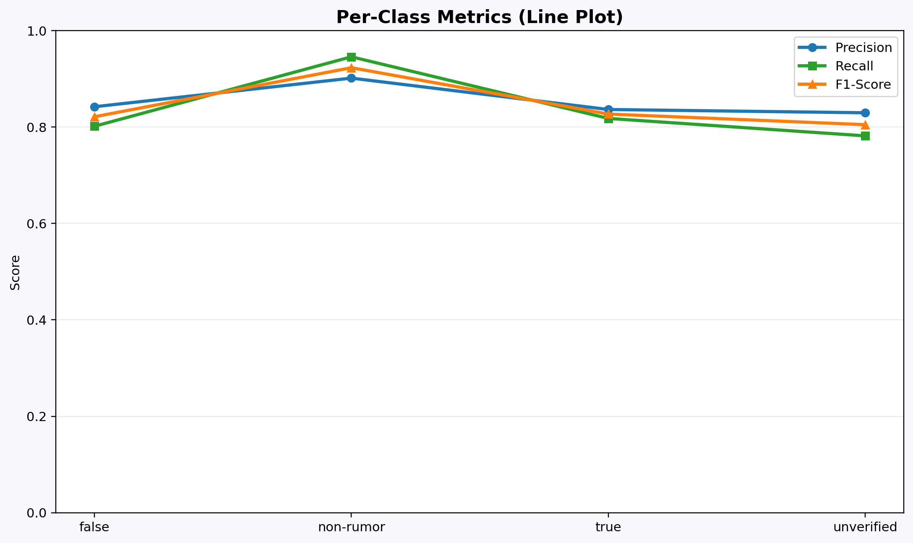
Polished Heatmap
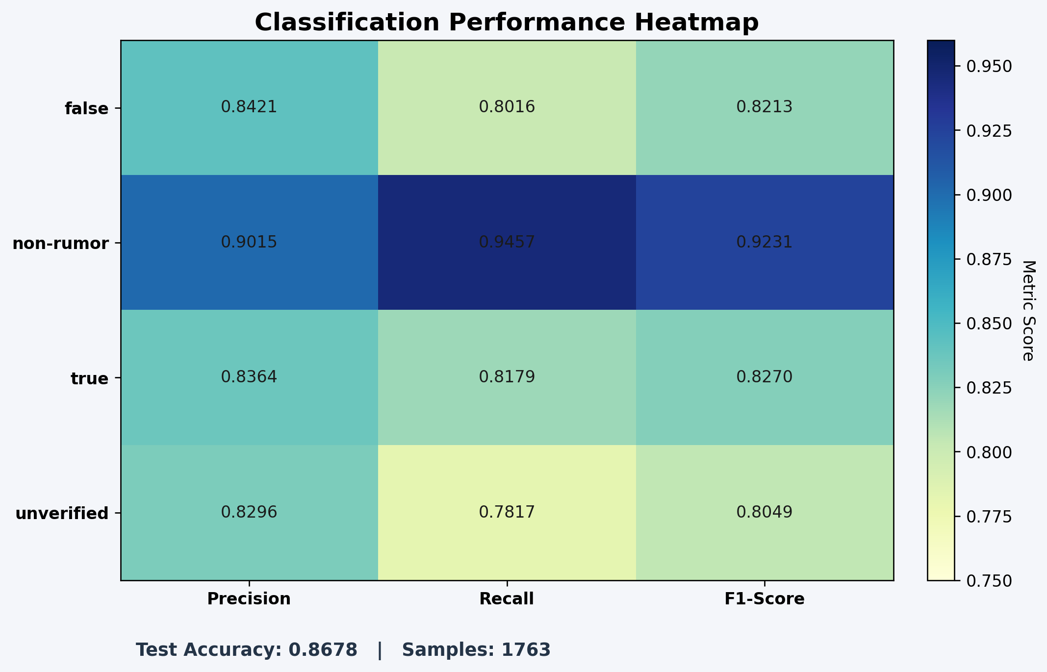

Conclusion and Future Scope
- The completed framework improves practical misinformation detection by combining semantic learning, emotional consistency, and factual validation in one pipeline.
- Compared to purely semantic augmentation workflows, emotion filtering improves training pair quality and supports stronger rumor-class behavior.
- The final evaluation design is deployment-friendly: baseline-only mode and fact-verification-enabled mode can be toggled via CLI without changing code.
- Future work should include multimodal rumor evidence (image/video), retrieval-augmented factual grounding from multiple trusted sources, and latency optimization for real-time monitoring.

References
- S. Vosoughi, D. Roy, and S. Aral, 'The spread of true and false news online,' Science, 2018.
- K. Shu et al., 'Fake news detection on social media: A data mining perspective,' ACM SIGKDD Explorations, 2017.
- H. Shen et al., 'LLM-Augmented Contrastive Learning for Misinformation Detection in Social Networks,' IEEE TCSS, 2026.
- T. Chen et al., 'A Simple Framework for Contrastive Learning of Visual Representations,' ICML, 2020.
- X. Feng et al., 'Bi-Level Graph Contrastive Learning for Rumor Detection,' ICDM, 2022.
- X. Hu et al., 'Leveraging Large Language Models for Fake News Detection via Multi-Perspective Reasoning,' CIKM, 2023.

